In this assignment, we trained a machine learning model and recorded key training statistics such as learning rate, loss, accuracy, and F1 score. These results were saved in NumPy .npy files for reproducibility and later analysis.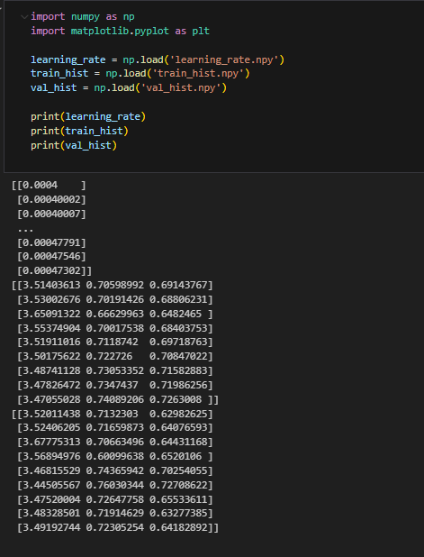
After loading the saved arrays, we use Matplotlib to visualize the learning process. The following code creates a 2×2 grid of subplots to display the evolution of key metrics during training.
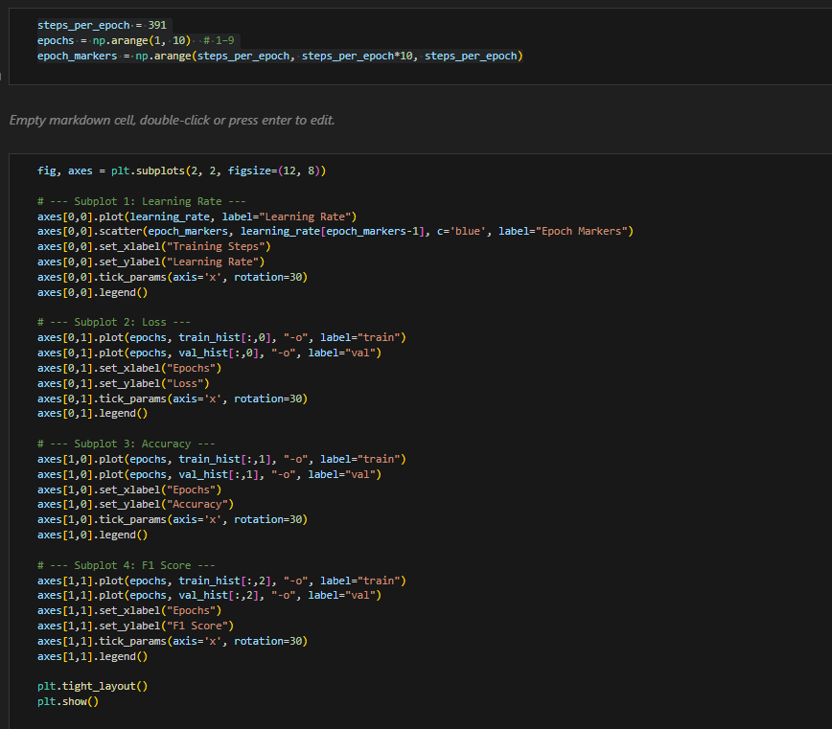
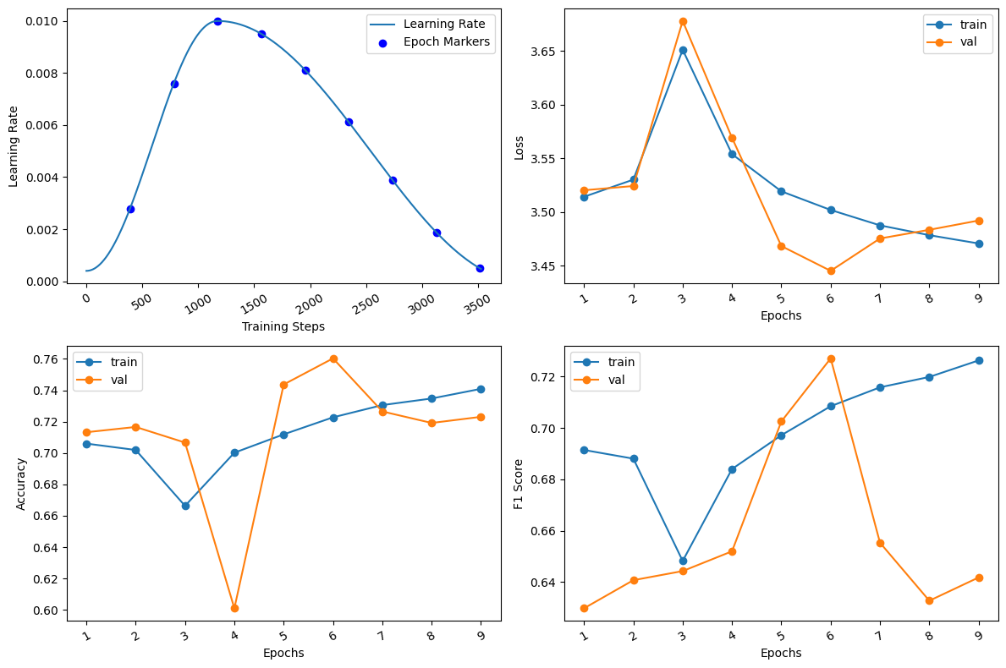
Results & Observations:
The following plots summarize the training process across 9 epochs.
- Learning Rate Schedule (Top-Left)
  - The learning rate follows a warm-up and decay pattern, starting low, increasing to a peak (~0.01), and then gradually decreasing.
  - This scheduling strategy helps the optimizer escape poor local minima during the early phase while ensuring stable convergence later.
- Loss Curve (Top-Right)
  - Both training and validation loss begin around 3.5–3.6.
  - Training loss shows a steady decline as epochs progress.
  - Validation loss follows a similar trend, though with slight fluctuations.
  - The convergence of both curves suggests the model is learning effectively without severe overfitting.
- Accuracy Curve (Bottom-Left)
  - Training accuracy gradually improves from ~0.70 to ~0.74 across epochs.
  - Validation accuracy fluctuates more sharply (notably dropping near epoch 4), but later stabilizes between 0.71–0.73.
  - The closeness of training and validation accuracy indicates a reasonable balance between learning and generalization.
- F1 Score Curve (Bottom-Right)
  - The F1 score increases for both training and validation datasets, peaking near epochs 5–6.
  - Validation F1 shows more volatility compared to training, reflecting the model’s sensitivity to unseen data.
  - Overall, the upward trend in F1 score demonstrates improved precision–recall balance as training progresses.

